# Worksheet 13

1. Load the opencv, matplotlib and numpy libraries.
2. 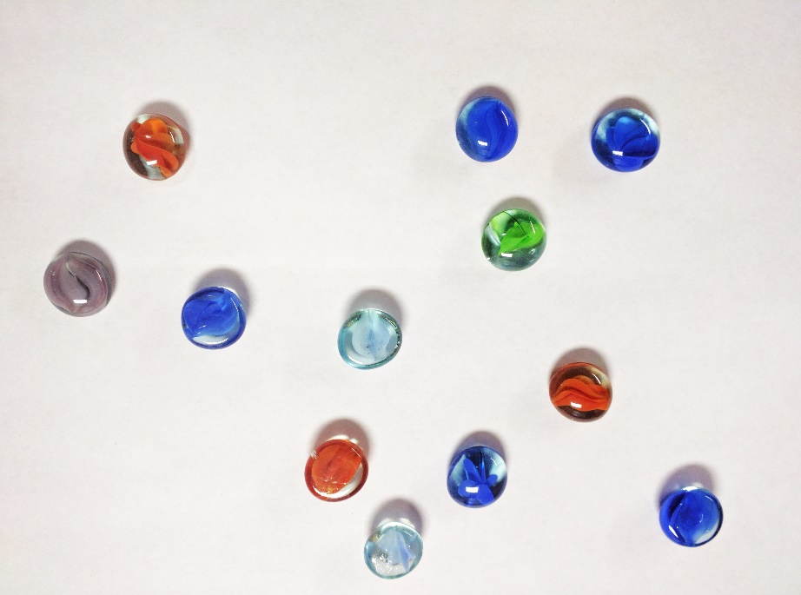Load beads.jpg in image matrix: IMG
3. Convert the image to grayscale
4. Apply a gaussian blur using a 5x5 kernel and sigma=2
5. Apply Canny edge detection. Experiment with lower and upper thresholds to obtain an image showing outlines similar to the following:

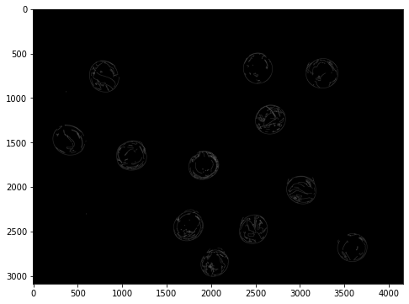

1. Research cv2.Houghcircles() to read and store the circles found in the image.
2. Iterate through the list of circles to display:
   1. The circles at the boundary of each marble.
   2. The centre of the circle.
   3. Display text of the number of circles found.

# Sample Output:

